
Dashboard Design

Date | 28 October 2026
Team ID | Not provided
Project Name | EV Market Analysis Dashboard using Tableau
Maximum Marks | 5 Marks

Creating an effective dashboard involves thoughtful design to ensure that the presented information is clear, relevant, and easily understandable for the intended audience. Here are some key principles and best practices for dashboard design
Activity 1: Interactive and visually appealing dashboards
Creating interactive and visually appealing dashboards involves a combination of thoughtful design, effective use of visual elements, and the incorporation of interactive features. Here are some tips to help you design dashboards that are both visually appealing and engaging for users so take care of below points
- Clear and Intuitive Layout
- Use Appropriate Visualizations
- Colour and Theming
- Interactive Filters and Slicers
- Drill-Down Capabilities
- Responsive Design
- Custom Visuals and Icons
- Use of Infographics

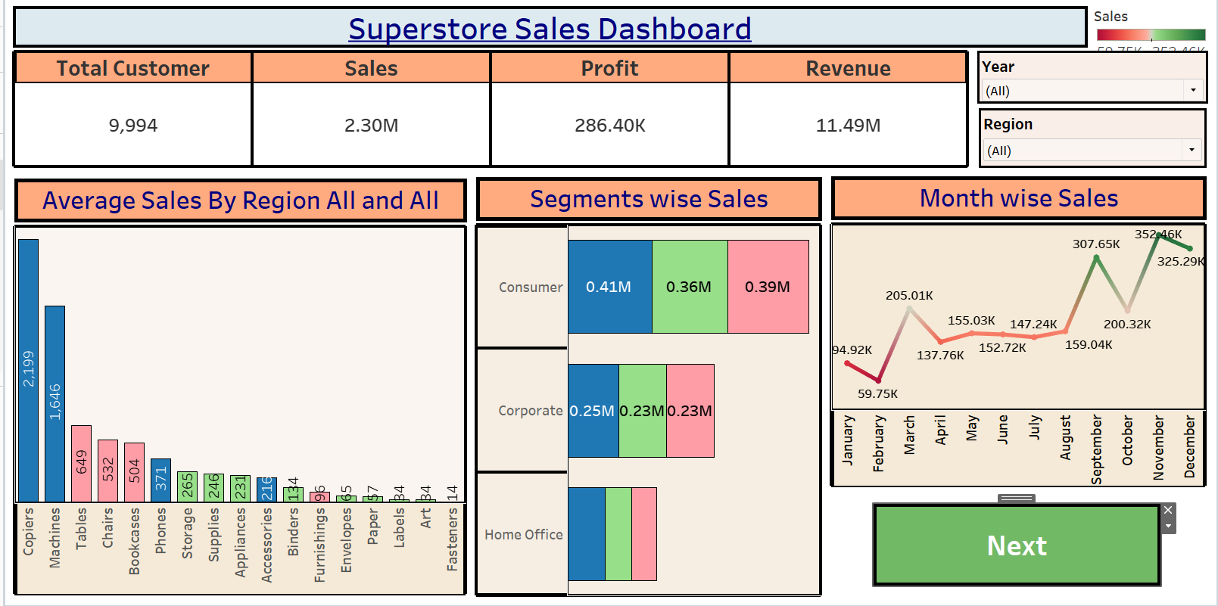
Note: Highlight the major outcomes in form of bullet points
Sample:
Here are five potential outcomes from the dashboard image provided:
- Customer Count and Sales Overview:The dashboard reports a total of 9,994 customers, with cumulative sales of 2.30M, a profit of 286.40K, and revenue of 11.49M. These figures highlight the overall scale and profitability of the store’s operations.
- Highest Sales: Copiers and Machines are the top-selling products, with sales values of 2.199M and 1.646M, respectively. This suggests strong demand or high price points for these products.
- Peak Month: December has the highest monthly sales at 352.46K, likely due to holiday shopping.
- Seasonal Sales Growth:The monthly sales chart shows growth in specific months, such as March, September, October, and December, likely influenced by seasonal factors and sales events.
- Sales Distribution Across Segments: The Consumer segment leads with 0.41M in sales, followed by Corporate at 0.25M, and Home Office at the lowest

Activity 2
Publish Dashboard on Tableau Public and Paste the Dashboard Public link below:
Example
https://public.tableau.com/views/SalesDashboard_17247660582000/Dashboard1?:language=en-US&publish=yes&:sid=&:redirect=auth&:display_count=n&:origin=viz_share_link

Activity 1: Interactive and visually appealing dashboards
Proposed dashboard layout: KPI cards for total EV models, average price, average range, average customer rating and total annual sales; charts for sales by manufacturer, range by model, price by category, charging time by category, and CO₂ savings. Add filters for manufacturer, model year, market region, category and battery type. Use consistent typography, readable labels, meaningful sorting and tooltips. Validate all figures against the source CSV.

Here are five potential outcomes from the dashboard image provided
• Compare EV models on price, range, battery capacity and charging time.
• Identify manufacturers with higher annual sales in the supplied dataset.
• Explore differences between EV categories and market regions.
• Compare customer ratings and safety ratings across vehicles.
• Identify vehicles with higher estimated annual CO₂ savings.
These are analysis objectives, not confirmed findings; replace with observations supported by your actual dashboard.

